**Backend Implementation**

I have attached Screenshots of functionalities implemented in Shopbridge Assessment. We have to do mainly 4 basic CRUD operations and tested using Postman app.I have attached all the reuired screen shot’s as well

1.Get operation to get all the list of available items.

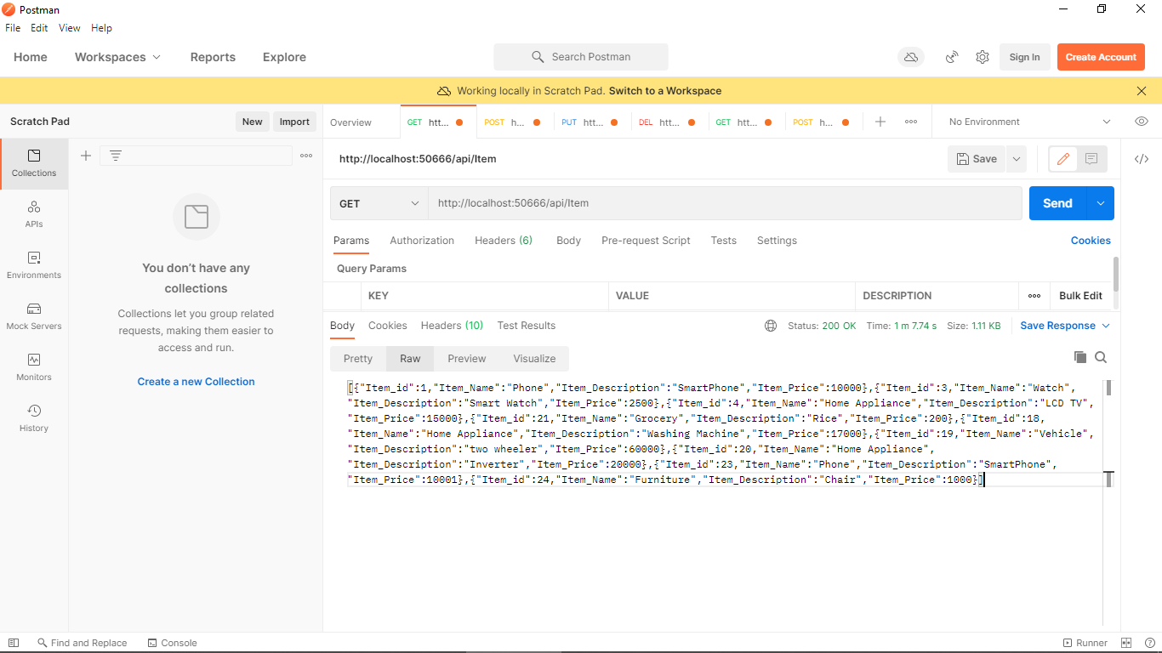

2 .Post Method is used to add new items to the database.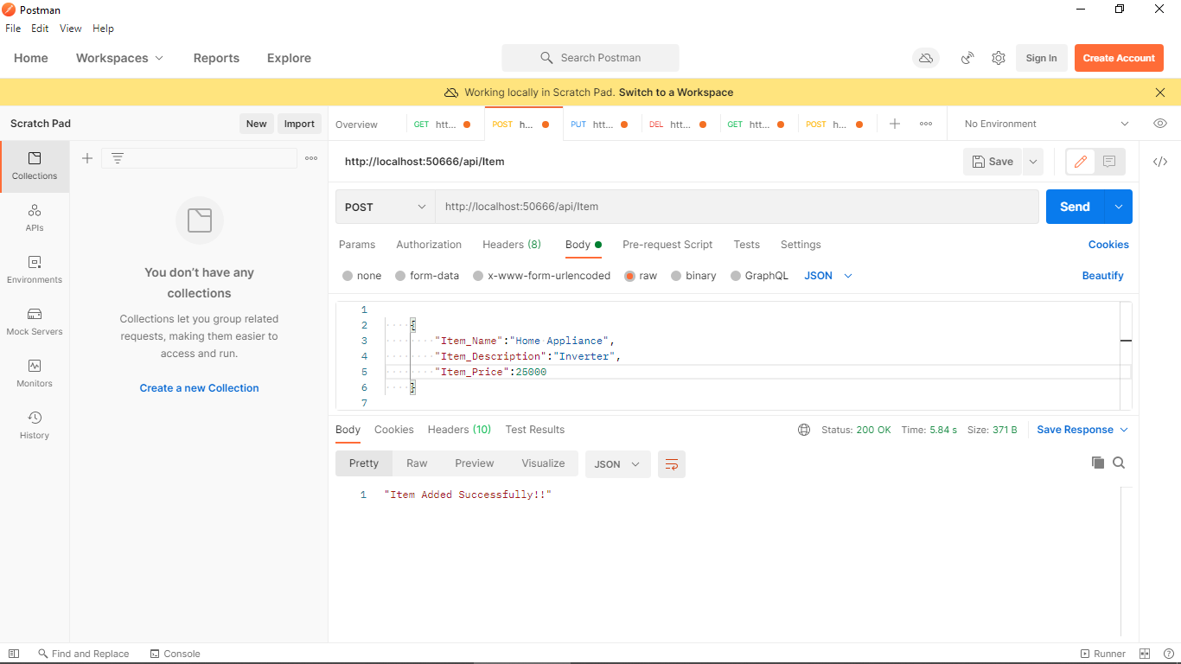

3. Put Method :To update any value related to items we can do it through put operations.

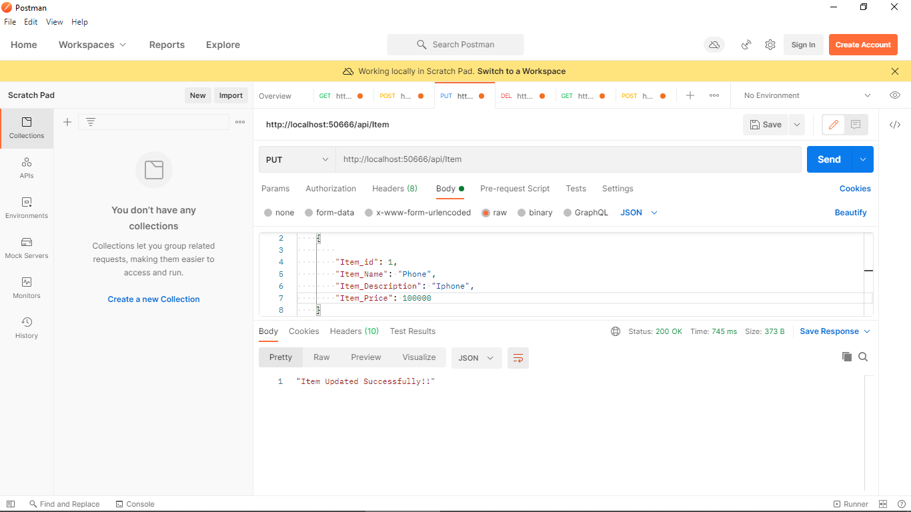

4. Delete Method: It is used to delete any item from database.

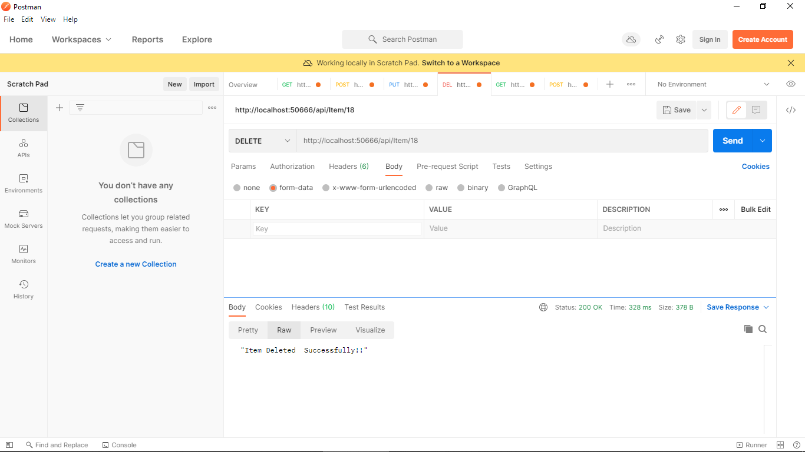

5. Get all item method is used to fetch all the available items in database.

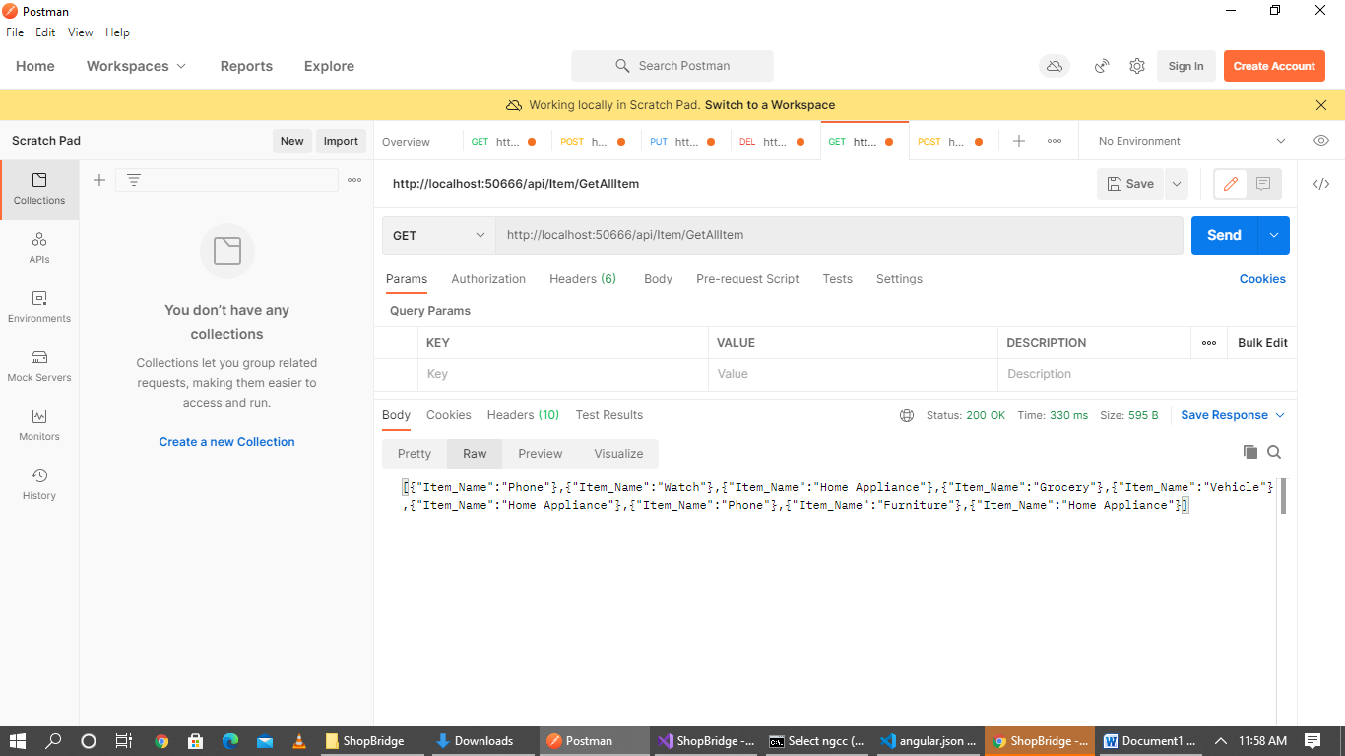

***Front-End Implementation***.

1 .Get Method: It is used to fetch all the available items using angular as front-end development .

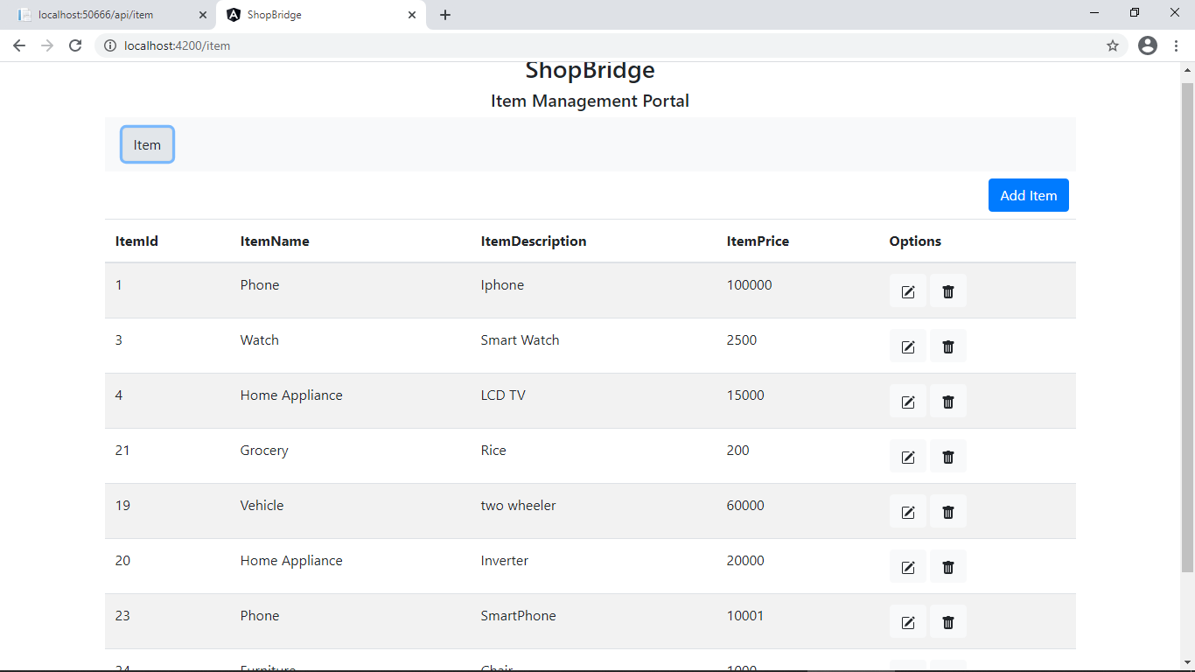

2. We can add new items from Add Item option given in portal. Below are two screenshots attached before and after POST command.

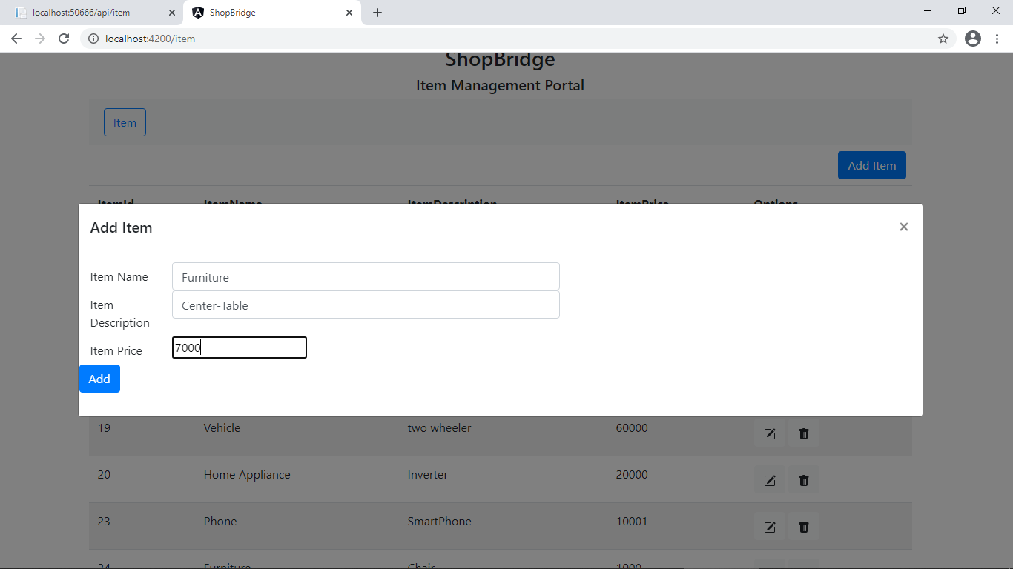

Above item is added with 1004 as item id.

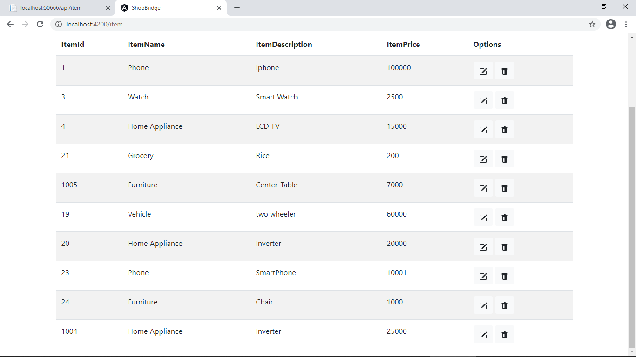

3. We can also use edit or delete option available as well .

I have updated Item Phone with item_id =1 to 70000 Price and attached screenshot’s as well.

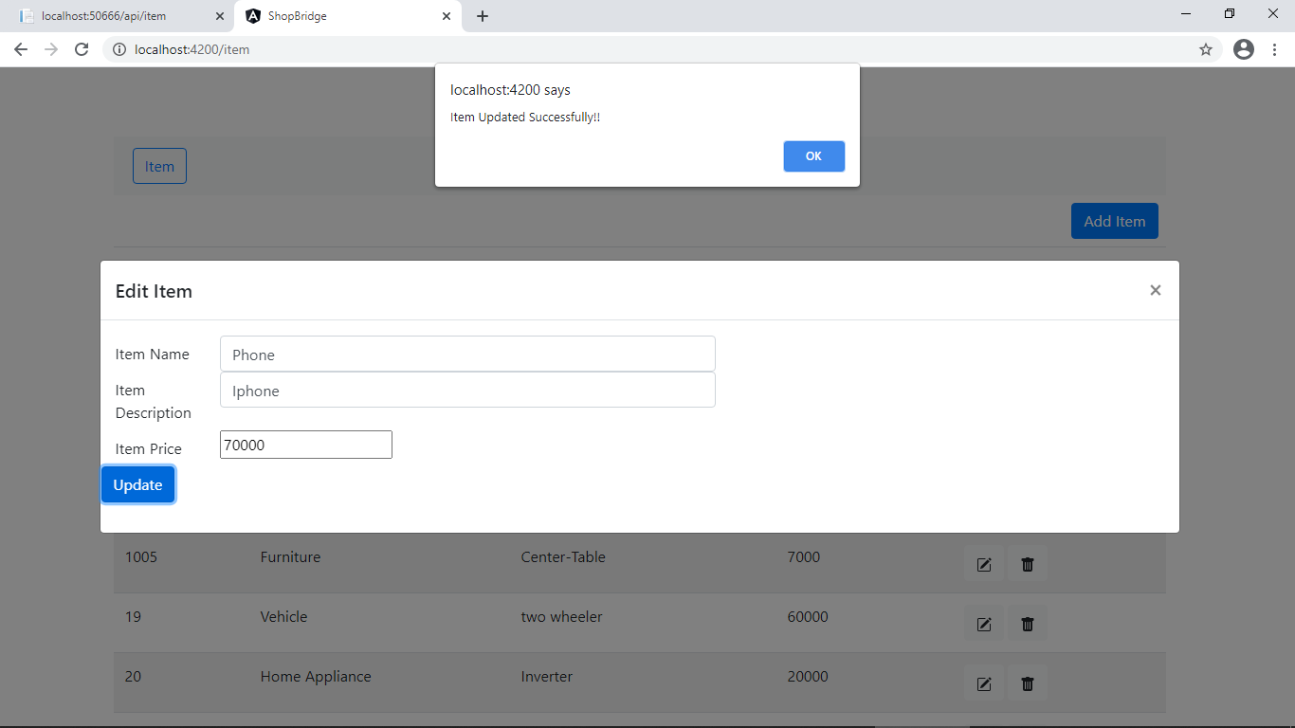

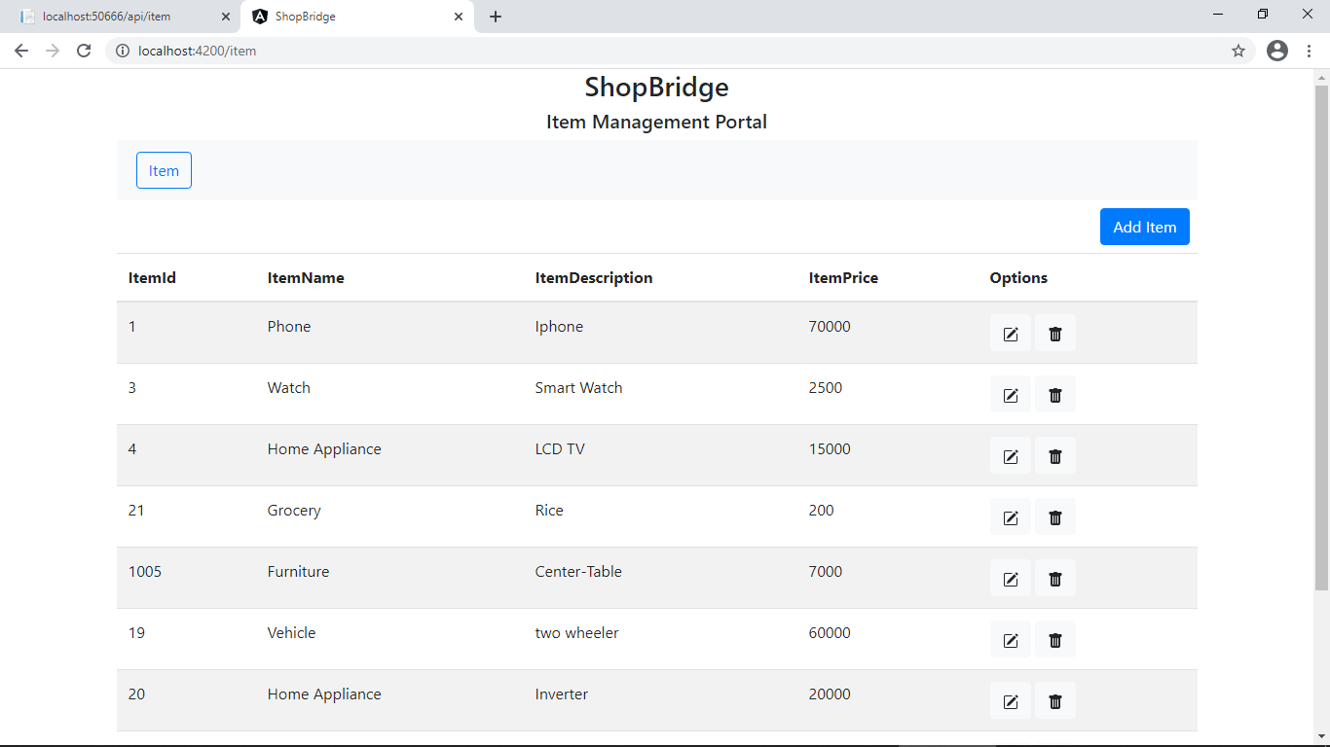

4. Delete operation: I am deleting phone item with Item_id =1 .

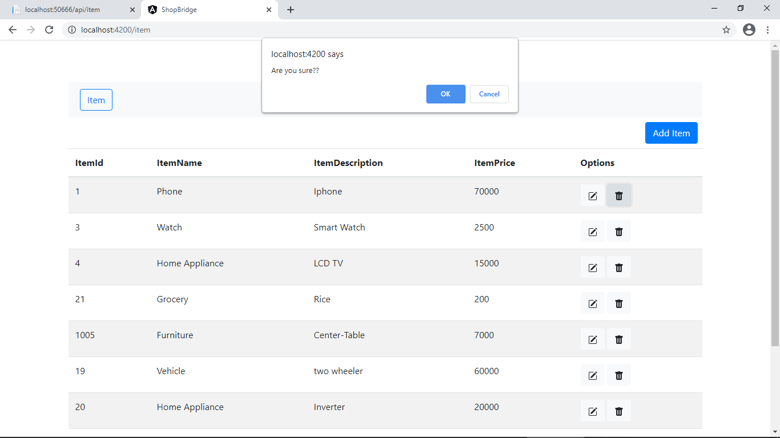

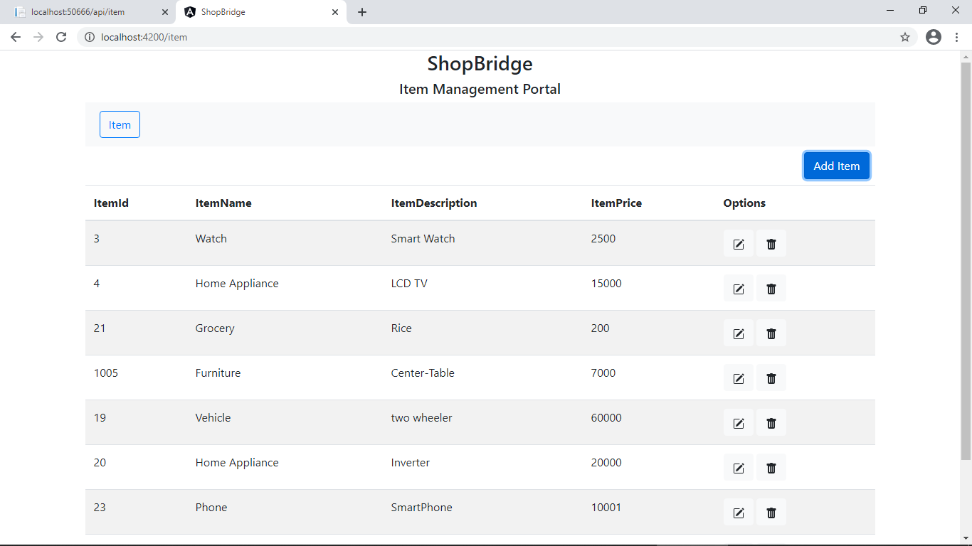

**Database Implementation**

1. Create table script screenshot.

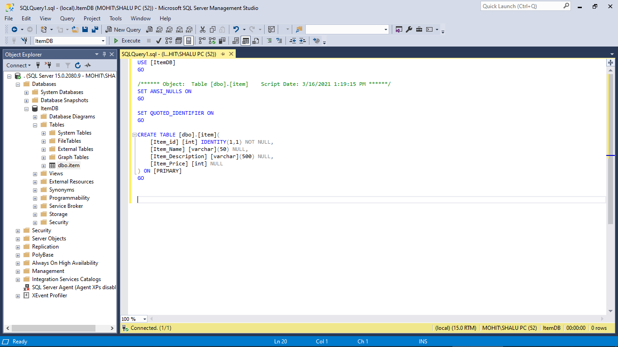

2. Fetching details from table.

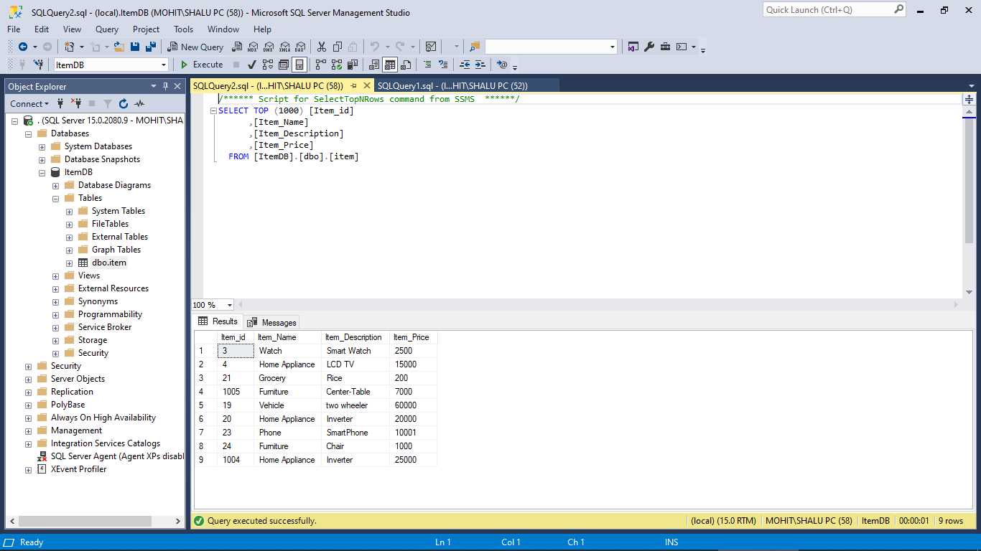

ShopBridge -Tracker

|  |  |  |
| --- | --- | --- |
| Item | Implementation | Time taken(hr) |
| 1 | Backend functionality +Database | 2 |
| 2 | Frontend functionality | 3 |
| 3 | Frontend Presentation | 1 |
| 4 | backend-frontend integration | 0.5 |
| 5 | Unit Test Coverage | 0.5 |

|  |
| --- |
|  |
|  |
|  |
|  |
|  |